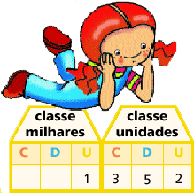

100 000 = 1 centena de milhar

100 000 = 10 dezenas de milhar

100 000 = 100 unidades de milhar

100 000= 1000 centenas

100 000= 10 000 dezenas

100 000= 100 000 unidades

|  |  |  |  |  |  |
| --- | --- | --- | --- | --- | --- |
| 1 | 6 | 3 | 3 | 8 | 5 |
|  |  |  |  |  |  |
|  |  |  |  |  |  |
|  |  |  |  |  |  |
|  |  |  |  |  |  |
|  |  |  |  |  |  |

Decompõe, conforme o exemplo:

100 000 + 60 000 + 3000 + 300 + 80 + 5

________________________________________________

________________________________________________

________________________________________________

________________________________________________

________________________________________________